
LOAN INVESTMENT MEMORANDUM
2 W Water St, Sag Harbor, NY 11963

Transaction Overview
Castellan Capital will provide a $22,270,000 senior loan to refinance the existing construction loan for two luxury waterfront single-family residences located at 2 West Water Street, Sag Harbor, NY. Turret Equities will provide a $3,930,000 junior loan subordinate to Castellan’s position. The borrower intends to repay both Castellan and Turret Equities through the sale of the properties.
Sponsorship Overview
- Business background: The sponsor, Mr. Jay Bialsky, is a real estate developer based in the Hamptons with over 30 years of experience. Mr. Bialsky is the owner of JBialsky Premiere Design and Development. As per the sponsor’s bio shared with Castellan, JBialsky Premiere Design and Development focuses on the development and construction of luxury residential properties in the East End of Long Island, including Sag Harbor and the broader Hamptons market.
- Personal financials: Based on the personal financial statement shared by Mr. Bialsky, he has a net worth of $30MM, which is majorly comprised of real estate assets.
- Background & credit check results: Castellan engaged Eaglescreen to perform civil and criminal record checks on the borrower. Based on the results, no judgments, liens, or adverse findings material to Castellan’s loan were identified. In addition, online searches did not reveal any derogatory or adverse information about the sponsor.
Submarket Overview
The subject property is located in Sag Harbor Village within the Hamptons, a premier luxury residential market in Suffolk County, NY. The area is characterized by a highly affluent buyer base and strong demand for waterfront estates, driven by second-home ownership and proximity to New York City. Median household income in the area is approximately $119,000, with significantly higher wealth levels among second-home owners and luxury buyers. Sag Harbor offers a mix of historic character, marina access, and high-end retail and dining, making it a desirable destination for both seasonal and year-round residents.

Business Plan
The sponsor’s business plan is to refinance the existing construction loan and provide additional time to market and sell the two luxury waterfront residences, each of which has access to boat slips. The sponsor intends to repay the debt through the sale of these properties.

Risks and Mitigants
- LTV Risk: Castellan’s estimated loan-to-value ratio is 52%, based on the “As Complete” appraised value of $43,000,000 provided by Platinum Appraisals. Castellan supports this value based on the firm’s independent underwriting and analysis of comparable sales and rentals. We believe that the strong basis in the loan can facilitate a potential sale of the Note in the event of a default. Castellan has developed relationships with defaulted note buyers and has sold several non-performing loans in the past. Additionally, the junior loan provided by Turret Equities serves as another layer of protection for Castellan’s loan, since in an event of default, the junior lender will have to keep Castellan current to preserve its equity in the deal.

- Sponsor Risk: This is Castellan’s first loan with Mr. Bialsky; however, based on his background, he is an active real estate developer with experience developing luxury residential properties in the Hamptons. A personal guaranty of payment and performance from Mr. Bialsky will serve as additional security for the loan.

- Interest Rate/Return Risk: Castellan’s interest rate is floating based on 1-Month CME SOFR index and is not capped. The effective rate at closing is expected to be 8.75%. Castellan’s loan has a floor rate of 8.75% as well should rates fall. Castellan’s rate on advances from its leverage facility is also based on the same index rate used in the underlying loan. This way, the rates move in tandem with limited negative effect on Castellan’s returns.

- Insurance Risk: Each property carries liability insurance of $1,000,000 per occurrence and $2,000,000 in aggregate along with $5,000,000 umbrella policy. In reviewing insurance coverage, the firm relies on each of the following: the insurance coverage for similar types of properties in its existing portfolio of loans; an independent review and recommendation from IMA Corp, which is Castellan’s main insurance agent

Loan Financials
Please see below for an overview of relevant loan metrics and other financial information about the property and transaction:
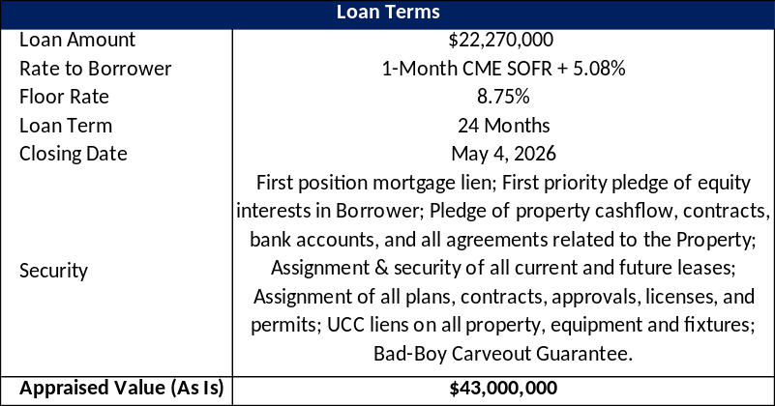

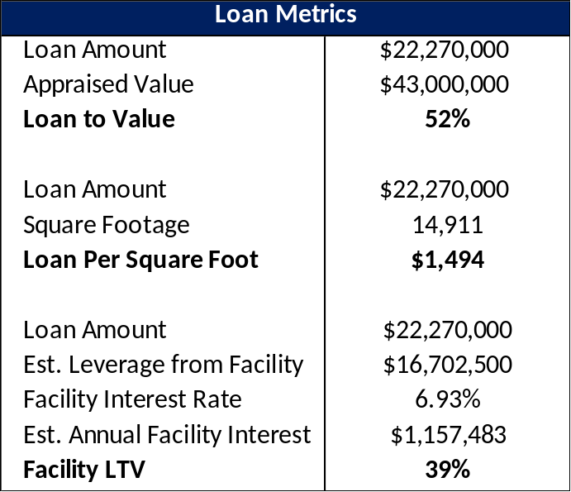
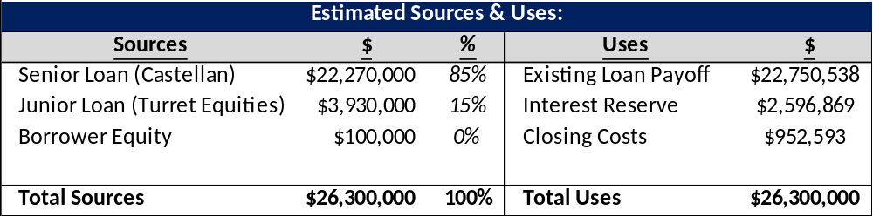

Investment Highlights
Castellan believes this is an attractive investment opportunity for the following reasons:
- This loan presents an attractive risk-adjusted return for a first-lien position in a residential property in Sag Harbor, NY.
- Castellan will be providing the loan on the property at a basis of $1,494/SF, while the average sales comps traded at $2,666/SF.
- A subordinate loan of $3,930,000 provided by Turret Equities effectively serves as another layer of security for Castellan.
- In the event the company comes into possession of the collateral, Castellan believes that it would have the potential to foreclose on the property and, if successful, take title at an attractive overall cost basis. Unlike traditional lenders, Castellan has the knowledge and infrastructure in place to successfully renovate, recapitalize and take ownership of the property.
Pictures
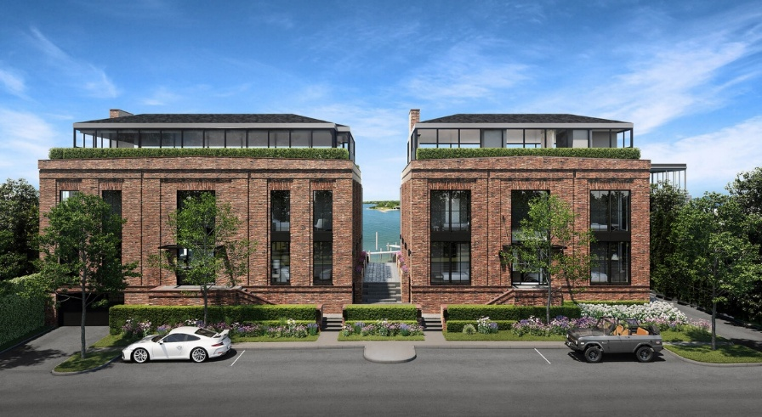

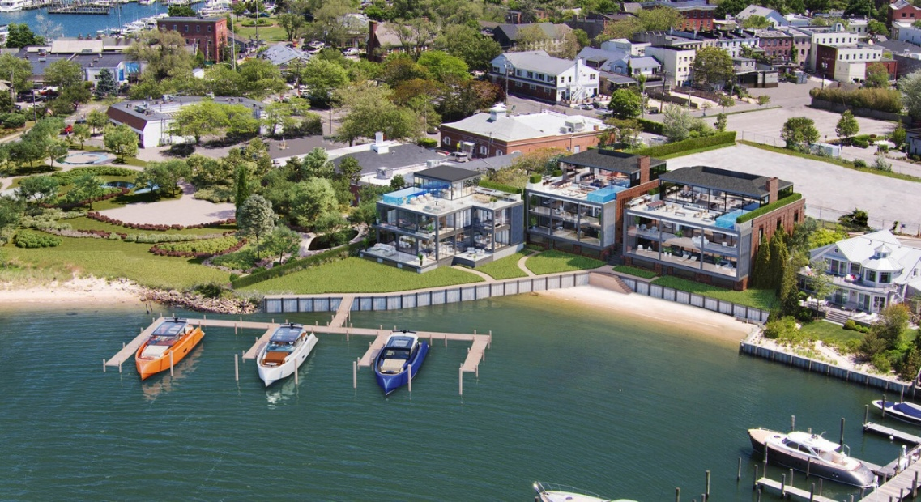
Map
